INF = 9999999
# number of vertices in graph
N = 5
#creating graph by adjacency matrix method
G = [[0, 19, 5, 0, 0],
[19, 0, 5, 9, 2],
[5, 5, 0, 1, 6],
[0, 9, 1, 0, 1],
[0, 2, 6, 1, 0]]
selected_node = [0, 0, 0, 0, 0]
no_edge = 0
selected_node[0] = True
# printing for edge and weight print("Edge : Weight\n")
while (no_edge < N - 1):
minimum = INF
a = 0
b = 0
for m in range(N):
if selected_node[m]:
for n in range(N):
if ((not selected_node[n]) and G[m][n]):
# not in selected and there is an edge
if minimum > G[m][n]:
minimum = G[m][n]
a = m
b = n
print(str(a) + "-" + str(b) + ":" + str(G[a][b]))
selected_node[b] = True
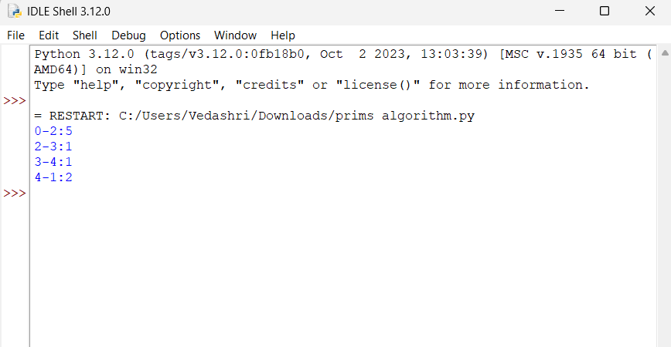
no_edge += 1

